**Course:** ENSF 337 – Fall 2020

**Lab #:** Lab 2

**Instructor:** M. Moussavi

**Student Name:** Quentin Jennings

**Lab Section:** B03

**Submission Date:** 2020-09-27

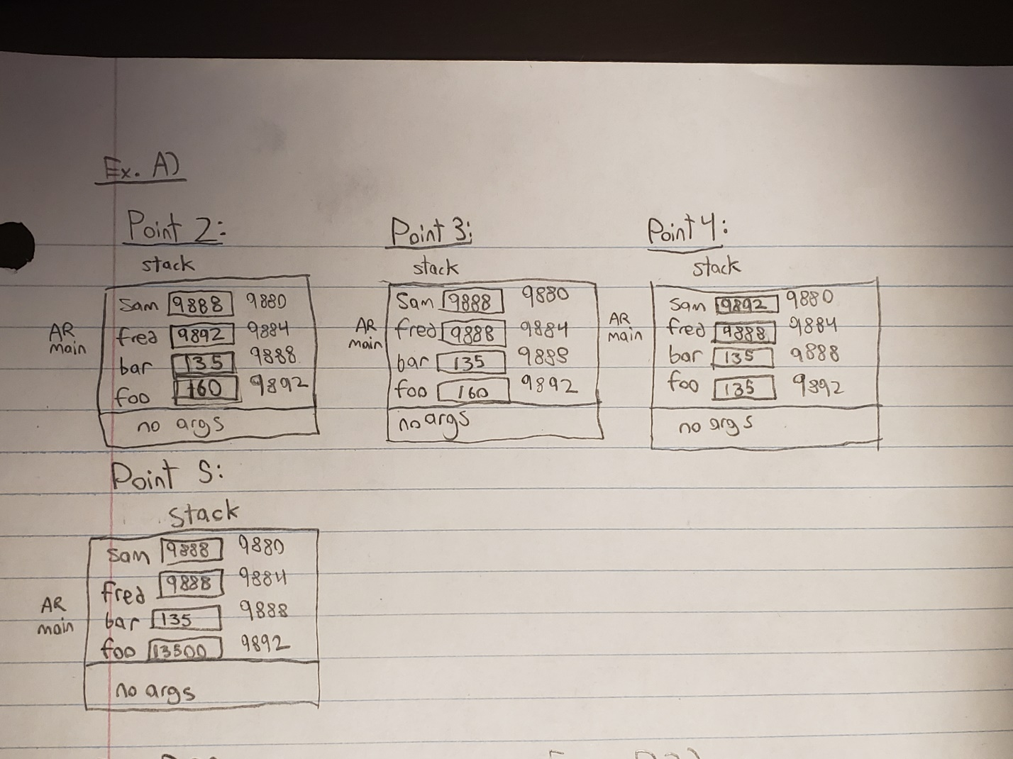

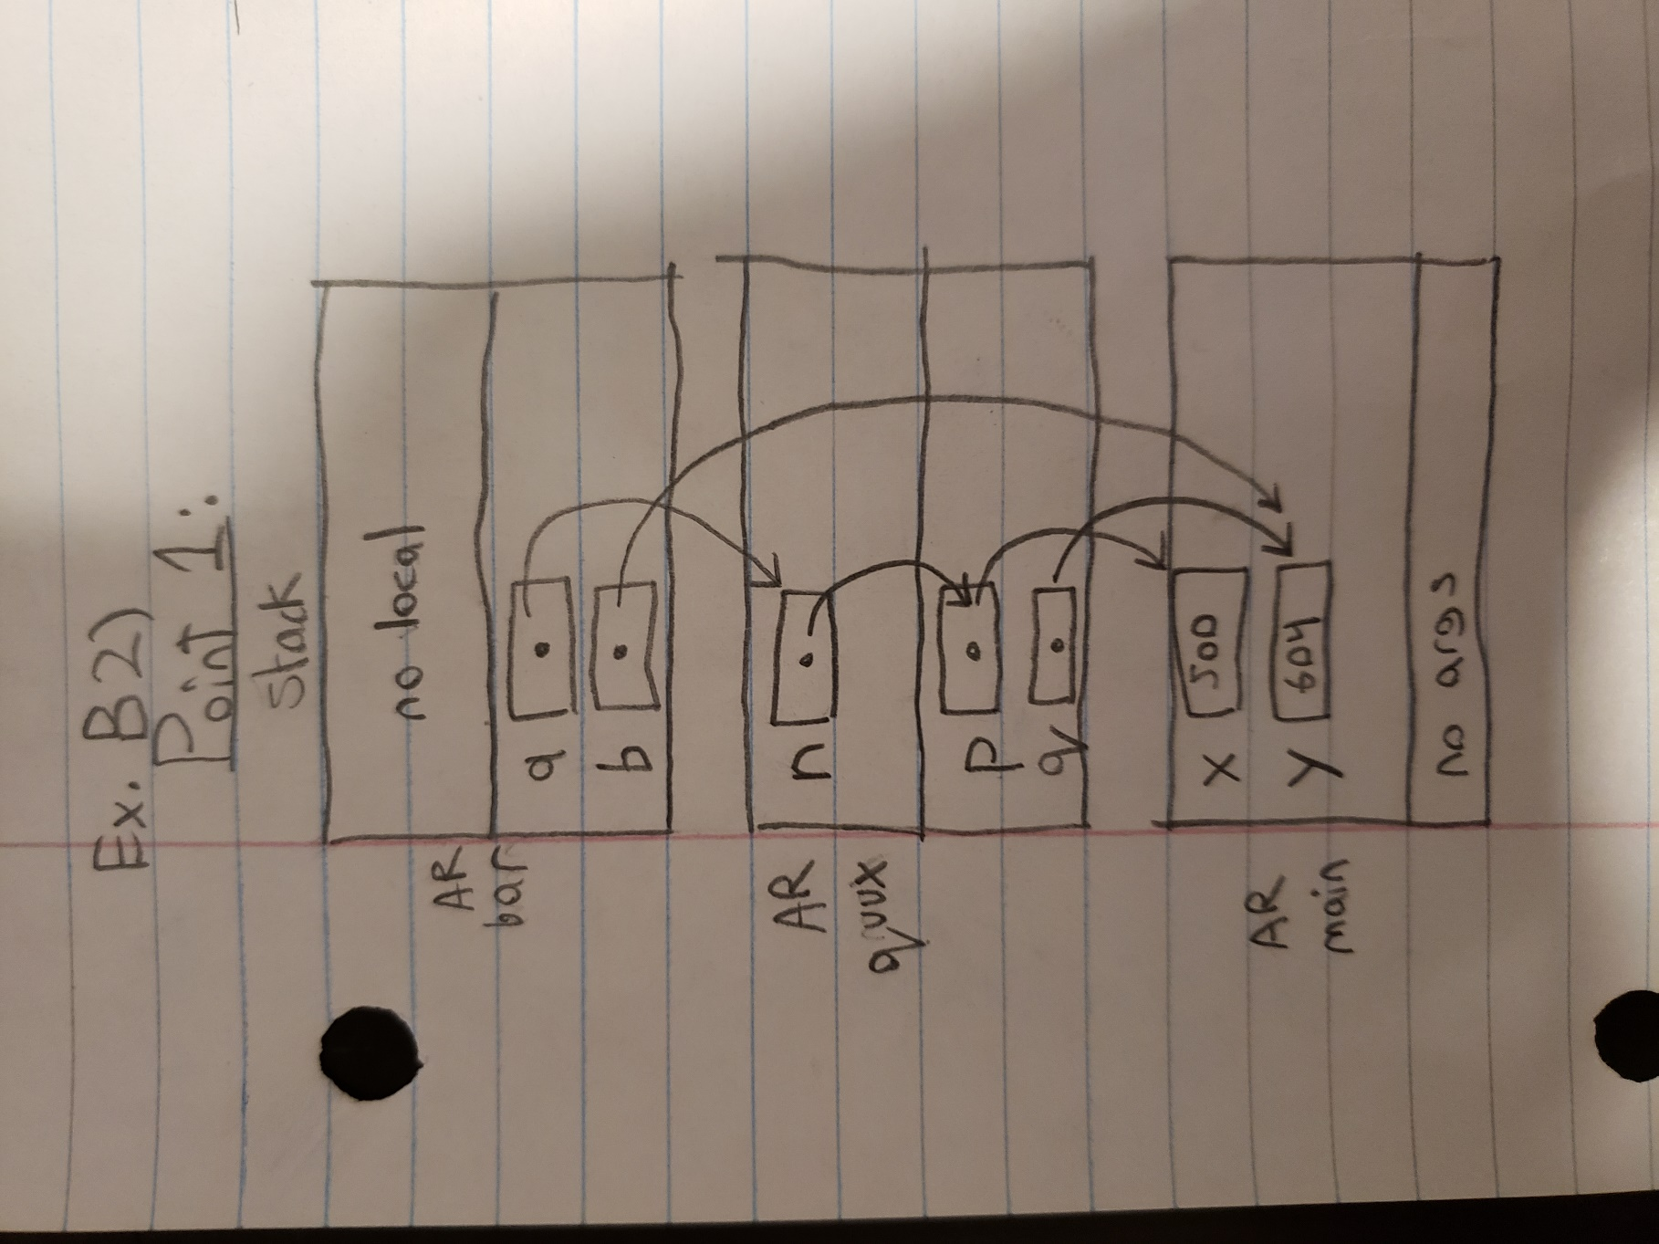

**Program C Output:**

Enter a time interval as an integer number of milliseconds: 123400

Doing conversion for input of 123400 ms ...

That is equivalent to 2 minute(s) and 3.400000 second(s).

